APPLICATION FORM FOR THE GUESTS OF THE ASAIHL Conference/University of Warsaw

25-28.09.2022
Block code: 2209ASAIHL

Classic Single Room 700 PLN gross / per night, breakfast included
Double/twin Room 754 PLN gross / per night, breakfast included

Above rates are in PLN for one room and one night. Rates are inclusive of breakfast in Restauran and inclusive of VAT tax (currently 8% subject to change*). Room rates include WiFi and unlimited access to the Victoria Pool and Fitness Club.
Check in time: from 3.00 p.m., check out time 12.00 a.m.
Family name_______________________________________________________________________
First name_________________________________________________________________________
Address__________________________________________________________________________
Phone number_____________________________________________________________________
E- mail___________________________________________________________________________
Dates of reservation: from ….. /09 /2022 to …. /09 /2022
Type of room:

Single Twin

Form of payment:

credit card
Name, number and expiry date of credit card: ___________________________________________________
Please note that Hotel will accept the reservation only with a credit card number (or prepayment) as a guarantee.

Rooms can be cancelled without any charge until 19.09.2022, 2pm. For any cancellation after this date guest will be charged for the whole stay.

Please kindly send back this application form to the Reservation Department of Sofitel Warsaw Victoria Hotel (e-mail: H3378-RE@sofitel.com) until 01.09.2022. After this date reservations will be accepted based on the hotel's availability.

We thank you very much for choosing Sofitel Warsaw Victoria and we wish you a magnifique stay in our hotel!

* In the event of changes to VAT values resulting from new taxing regulations an additional VAT charge, will be added to the net prices, according to the official VAT value of the day of the stay.

I authorize Hotel to debit my credit card, as the payment of ordered services. The credit card will be charged by the Hotel.
GUEST signature………………………..

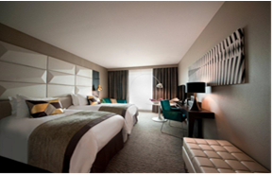
Superior Room
The spacious, air-conditioned rooms
with individual monitoring have been designed
especially for business and individual travelers.
They all feature the luxury “MyBed” –
Sofitel exclusivity for a perfect sleep, safe,
coffee/tea facilities, mineral water, and WiFi
.
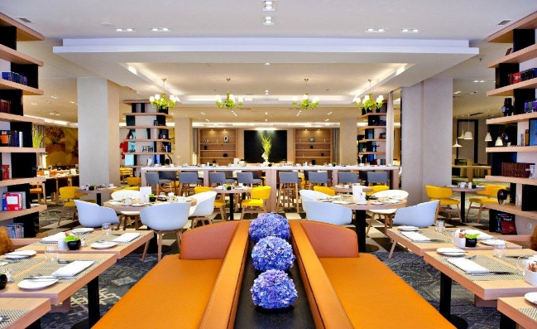
Breakfast
Our Executive Chef – Paweł Kałuski
invites you to a wealthy breakfast buffet,
with Polish specialties as well as French patisserie,
a large selection of warm and cold dishes,
fresh juices. Enjoy a real breakfast feast
and start the day with a smile.

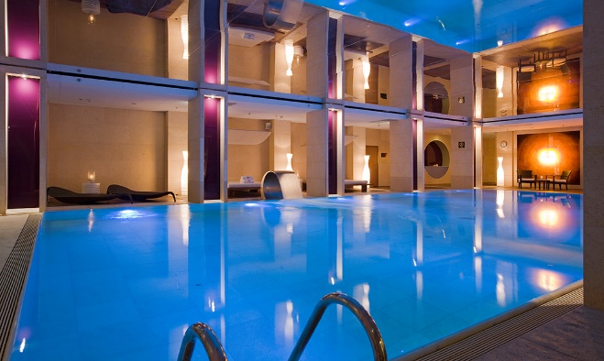
Victoria Pool and Fitness Club
The Victoria Pool and Fitness Club
is an extraordinary place in the hotel.
The beautifully designed swimming pool,
Fitness and sauna are an encouragement
to relax and naturally replenish your energy.
It exclusively for the hotel Guests.

